**Step 1: download the code from Stash.**

 Git Path :<http://mydtbld0005.hpeswlab.net:7990/login?next=/projects/EIAP/repos/ei/browse>

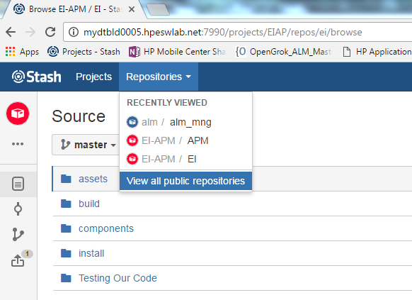

One is EI, then second this APM.

EI project reference APM.

Import both of the two projects in you IDE environment (Eclipse) like the following picture.

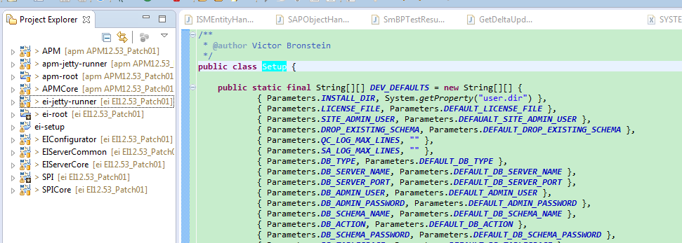

**Step 2:create siteAdmin DB:(you should install SQL SERVER or Oracle).**

**(1):** create one projcet named: ei-setup(maven project) one pom.xml file and one HP_ALM_(version number like 11_50)_Permanent_Unlimited.dat ALM liencse file.

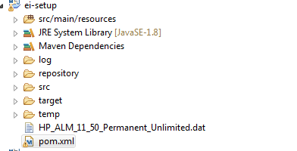

pom.xml contents:

<project xmlns="<http://maven.apache.org/POM/4.0.0>" xmlns:xsi="<http://www.w3.org/2001/XMLSchema-instance>"

    xsi:schemaLocation="<http://maven.apache.org/POM/4.0.0> <http://maven.apache.org/maven-v4_0_0.xsd>">

    <modelVersion>4.0.0</modelVersion>

    <artifactId>ei-setup</artifactId>

    <name>${project.artifactId}</name>

    <parent>

        <groupId>com.hp.alm.ei</groupId>

        <artifactId>ei-root</artifactId>

        <version>12.50.1.9999-SNAPSHOT</version>

        <relativePath>..</relativePath>

    </parent>

    <dependencies>

        <dependency>

            <groupId>com.hp.alm.platform</groupId>

            <artifactId>alm-install</artifactId>

            <version>${alm.platform.version}</version>

        </dependency>

        <dependency>

            <groupId>${project.groupId}</groupId>

            <artifactId>SPI</artifactId>

            <version>${project.version}</version>

        </dependency>

        <dependency>

            <groupId>javax.jms</groupId>

            <artifactId>jms</artifactId>

            <version>1.1</version>

        </dependency>

        <dependency>

            <groupId>javax.servlet</groupId>

            <artifactId>javax.servlet-api</artifactId>

            <version>3.1.0</version>

        </dependency>

        <dependency>

            <groupId>org.apache.neethi</groupId>

            <artifactId>neethi</artifactId>

            <version>3.0.2</version>

        </dependency>

        <dependency>

            <groupId>org.opensaml</groupId>

            <artifactId>xmltooling</artifactId>

            <version>1.3.2-1</version>

            <scope>runtime</scope>

            <exclusions>

                <exclusion>

                    <groupId>org.slf4j</groupId>

                    <artifactId>log4j-over-slf4j</artifactId>

                </exclusion>

                <exclusion>

                    <groupId>org.apache.santuario</groupId>

                    <artifactId>xmlsec</artifactId>

                </exclusion>

                <exclusion>

                    <groupId>org.bouncycastle</groupId>

                    <artifactId>bcprov-jdk15</artifactId>

                </exclusion>

            </exclusions>

        </dependency>

        <dependency>

            <groupId>org.opensaml</groupId>

            <artifactId>openws</artifactId>

            <version>1.4.2-1</version>

            <scope>runtime</scope>

            <exclusions>

                <exclusion>

                    <groupId>org.slf4j</groupId>

                    <artifactId>log4j-over-slf4j</artifactId>

                </exclusion>

            </exclusions>

        </dependency>

        <dependency>

            <groupId>org.apache.ws.security</groupId>

            <artifactId>wss4j</artifactId>

            <version>1.6.12</version>

            <scope>runtime</scope>

            <exclusions>

                <exclusion>

                    <groupId>org.slf4j</groupId>

                    <artifactId>log4j-over-slf4j</artifactId>

                </exclusion>

                <exclusion>

                    <groupId>org.apache.santuario</groupId>

                    <artifactId>xmlsec</artifactId>

                </exclusion>

            </exclusions>

        </dependency>

        <dependency>

            <groupId>org.opensaml</groupId>

            <artifactId>opensaml</artifactId>

            <version>2.5.1-1</version>

            <scope>runtime</scope>

            <exclusions>

                <exclusion>

                    <groupId>org.slf4j</groupId>

                    <artifactId>log4j-over-slf4j</artifactId>

                </exclusion>

            </exclusions>

        </dependency>

        <dependency>

            <groupId>org.owasp.esapi</groupId>

            <artifactId>esapi</artifactId>

        </dependency>

        <dependency>

            <groupId>com.sun.xml.bind</groupId>

            <artifactId>jaxb-impl</artifactId>

            <type>jar</type>

            <scope>compile</scope>

        </dependency>

        <dependency>

            <groupId>com.sun.xml.messaging.saaj</groupId>

            <artifactId>saaj-impl</artifactId>

            <version>1.3.19</version>

            <scope>runtime</scope>

            <exclusions>

                <exclusion>

                    <groupId>activation</groupId>

                    <artifactId>activation</artifactId>

                </exclusion>

            </exclusions>

        </dependency>

        <dependency>

            <groupId>javax.xml.soap</groupId>

            <artifactId>saaj-api</artifactId>

            <version>1.3.4</version>

            <scope>runtime</scope>

        </dependency>

        <dependency>

            <groupId>commons-lang</groupId>

            <artifactId>commons-lang</artifactId>

            <version>2.3</version>

        </dependency>

    </dependencies>

</project>

**(2):**config ei-setup Java Application:

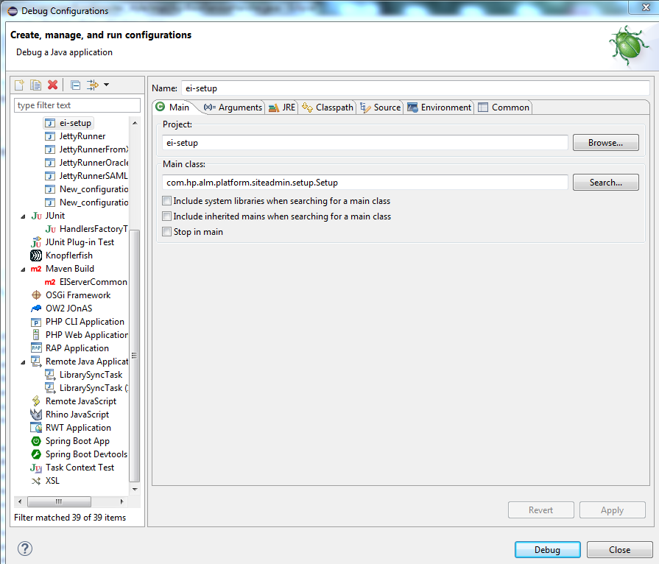

**(3):** After running ei-setup, ALM DB Setup as follows

           Output folder: SiteAdmin.xml file output path

           License File: ALM license path

           Site Admin User Name:  SiteAdminstartor

           Site Admin Password:

           Schema password: default: tdtdtd

           Admin User : database user

           Admin Password: database user password

           Schema name : database name you will create

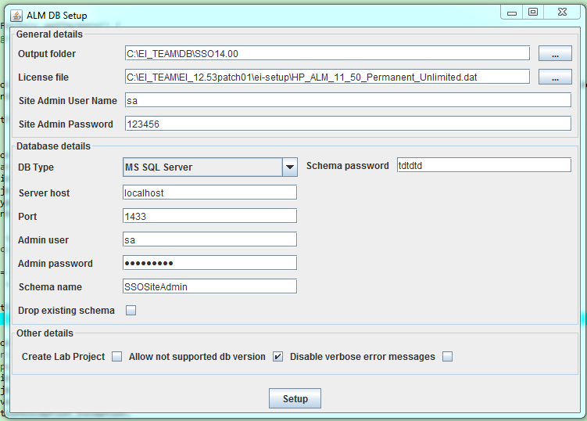

**Step 3: run ei-jetty-server to start alm server in eclipse or idea.**

**(1) config run configuartion like the following picture**

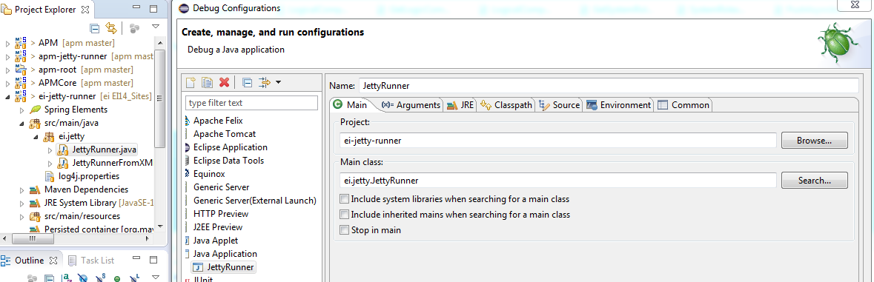

    About the arguments like the following picture

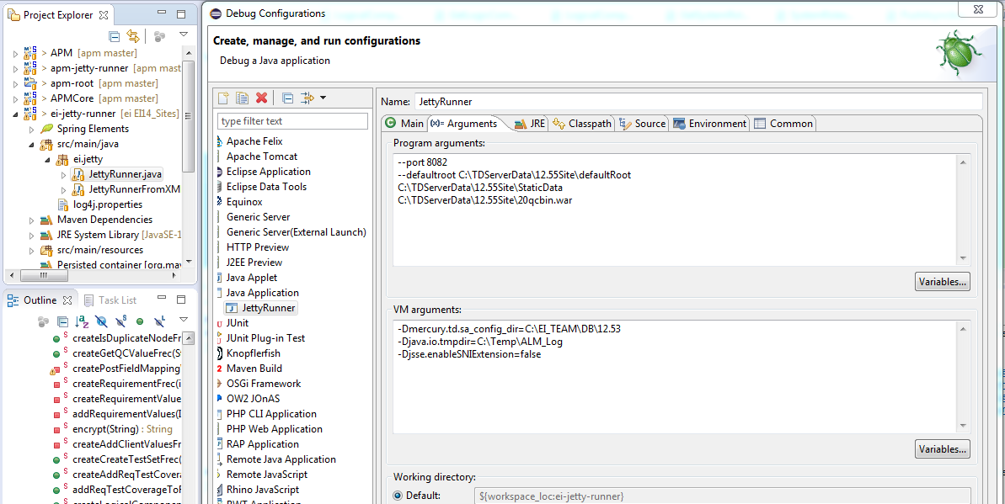

VM arguments

    -Xmx512m -XX:MaxPermSize=512m  
    -Dmercury.td.sa_config_dir=C:\ProgramData\HP\ALM\webapps\qcbin\WEB-INF (siteAdmin.xml file path where you generated this file when create SiteAdmin DB)

         --port: which port you will use to start alm server like http://localhost:**port**/qcbin/

         --defaultroot there are three parts you need to copy from alm path. this two folders copy path like

         \\mydastr01.hpeswlab.net\products\TestDirector\ALMDev\ALM1255\ALM1255\Archives\12.55.2529.0.0\Development_StaticData\TDServer.

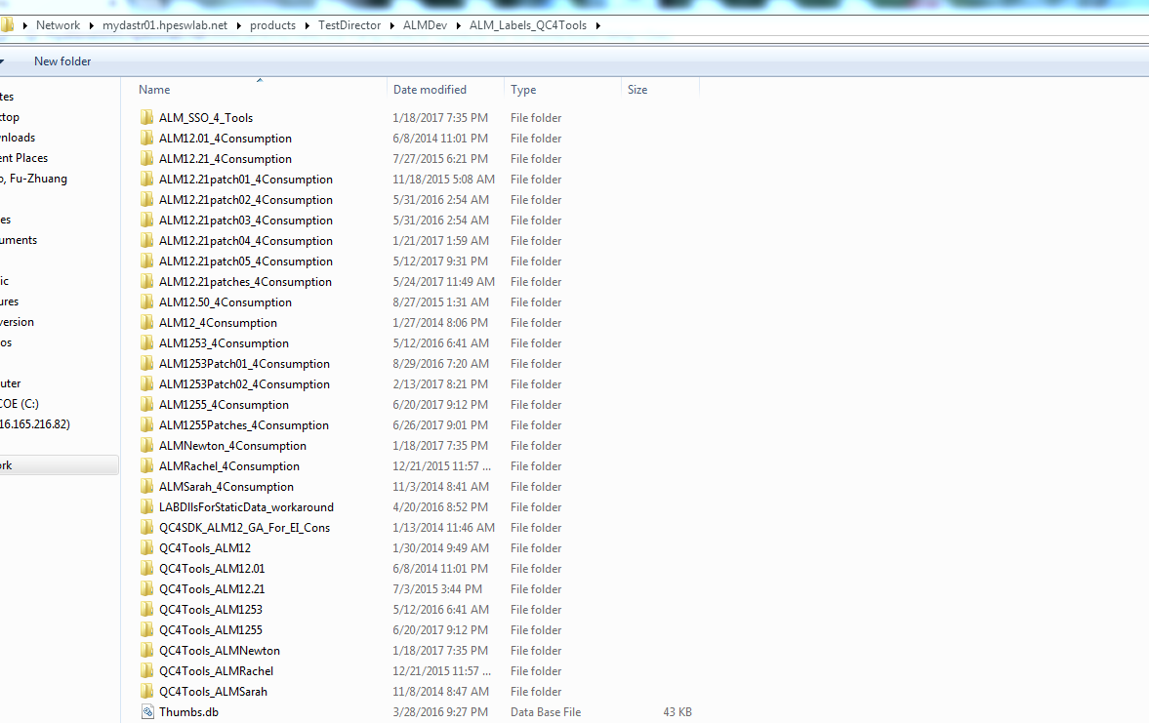

P:\TestDirector\ALMDev\ALM_Labels_QC4Tools\ALM1255_4Consumption\Development_StaticData\TDServer

20qcbin.war is our own merge two parts APM and EI build files.

\\mydastr01.hpeswlab.net\products\QC_for_SAP

\\mydastr01.hpeswlab.net\products\QC_for_SAP\EI\EI12.00\alm1255_stb.latest\SPI.qcx\application\20qcbin.war

\\mydastr01.hpeswlab.net\products\QC_for_SAP\APM\APM12.00\alm1255_stb.latest\APM.qcx\application\20qcbin.war

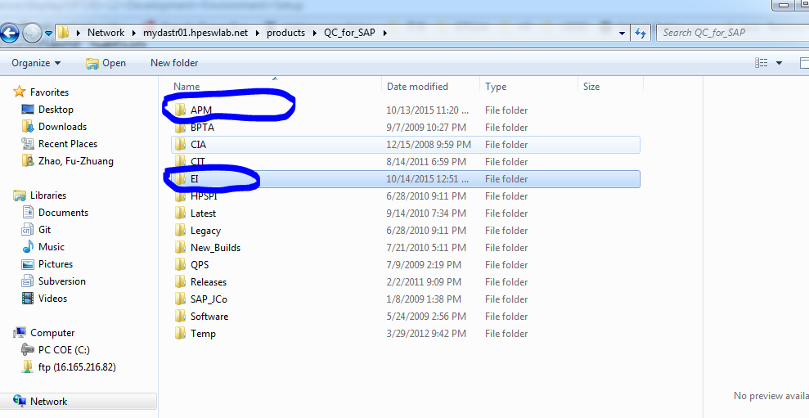

Then you can run-ei-jetty server configuration. ALM server with EI extension can start successfully.